Software Construction and Development (SCD)
Lab Task - Tasks 2 and 3
Name | Mubashir
Roll No. | 021
Class | BSSE-5A
Subject | Software Construction and Development (SCD)
Project | Clash-Free Course Timetable Scheduler (Genetic Algorithm)

Task 2: Design Patterns Used in the Semester Project
The semester project is a console-based Clash-Free Course Timetable Scheduler. It uses a genetic algorithm to assign courses to rooms and time slots without teacher, room, section or capacity clashes. Two design patterns, Singleton and Facade, are used in this project.
Pattern | Where it is used | How it is used | Benefit
Singleton | DataStore | Only one DataStore object exists in the whole program. It is accessed through the getInstance() method instead of creating new DataStore objects in different places. All CSV reading and writing goes through this one point. | Avoids two instances overwriting each other's backups or reading stale data.
Facade | GeneticScheduler and DataStore | GeneticScheduler.run() hides population setup, selection, crossover, mutation and elitism behind one call; Main just calls run() and gets back a timetable. DataStore.loadTeachers() and saveTeachers() hide the file I/O, backup copying and defensive parsing. | Callers use one simple method instead of many internal steps.

Task 3: Use Case Diagram and Class Diagram

3.1 Use Case Diagram
The system has one actor, the Admin, who operates everything through the console menu. Generate Timetable includes Run Genetic Algorithm, which includes Evaluate Fitness, which includes Validate Conflicts. Manually Override a Slot includes Validate Affected Constraints. View by Section, Teacher and Room extend View Timetable.
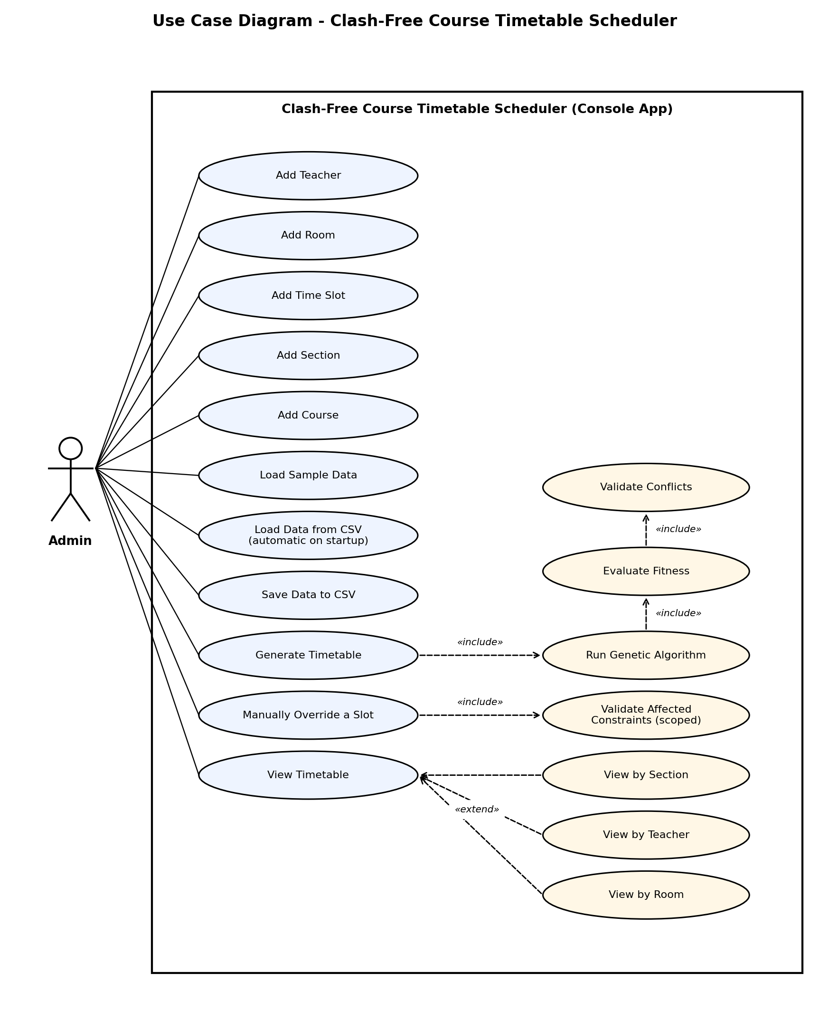
Figure 1: Use case diagram

3.2 Class Diagram
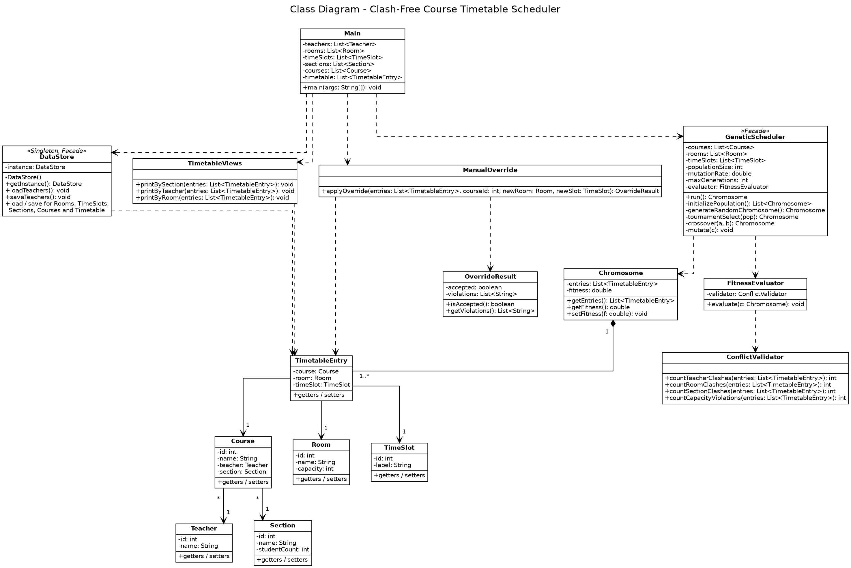
Figure 2: Class diagram
- Composition: a Chromosome is made up of one or more TimetableEntry objects, which do not exist outside a Chromosome.
- Association: TimetableEntry refers to a Course, a Room and a TimeSlot; many Courses can refer to the same Teacher or Section.
- Dependency: GeneticScheduler uses FitnessEvaluator, which uses ConflictValidator. Main uses DataStore, GeneticScheduler, TimetableViews and ManualOverride. ManualOverride returns an OverrideResult.
- Inheritance: none is used in this design.

